
President
Deborah Henry, MD

Vice President
Ciara Harraher, MD, MPH, FRCSC

President Elect
Javed Siddiqi, HBSc, MD, DPhil (Oxon)

Past President
Odette Harris, MD, MPH

Historian
Charles Nussbaum, MD
Secretary-Treasurer
J. Adair Prall, MD
5856 South Lowell Blvd Suite 32-411
Littleton, CO 80123
wnssecr.treas@gmail.com

The Western Neurosurgical Society

www.westnsurg.org

Dear WNS Members, Applicants, and Guests:
On behalf of our President, Dr. Deborah Henry, and the Executive Committee, we are happy to invite you to the 72nd annual meeting of the Western Neurosurgical Society!
We are again expecting a robust turnout as we gather in the beautiful Hawaiian Islands. This year’s meeting will be held at the Royal Sonesta Resort in Kauai, Hawaii. Only five minutes from the Lihue airport, the resort has many activities for participants, including shopping, fine dining, snorkeling, fishing and boating, as well as nearby golf, hiking and other planned activities for the meeting.
Please note that the opening reception will be Thursday night, September 24th, and the meeting will adjourn on Sunday, September 27th.
We can all look forward to a fantastic scientific program organized by Dr. Alex Khalessi and his committee. The theme of this year’s meeting is ‘Neurosurgical Wellness’. Please consider submitting an abstract now to be a part of the program – see form below!
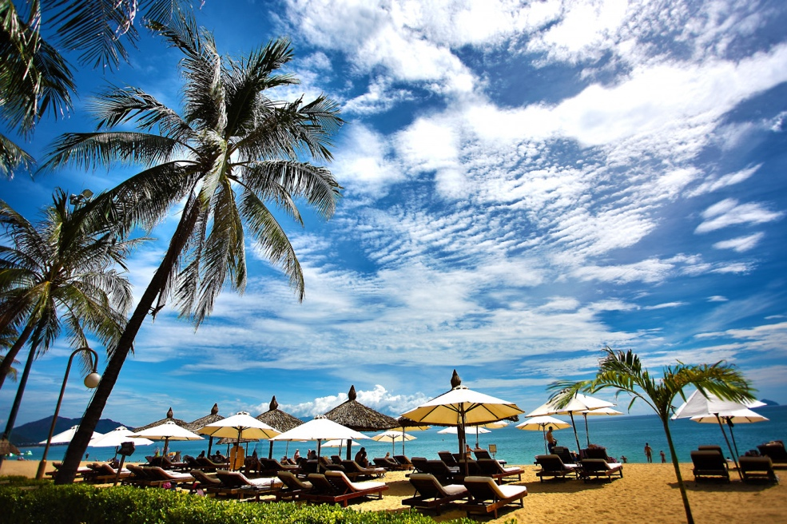
The 2026 Cloward Medal will be awarded to Dr. Laligam Sekhar. Well-known by all in the field of Neurosurgery, and in particular the members of the Western, Dr. Sekhar is recognized for his work in vascular and skull base neurosurgery and holds the position of Vice-Chair of the Department of Neurosurgery at the University of Washington.
This year’s Prolo Lecturer will be Dr. Rolando Del Maestro, a professor at McGill University and an Italian-born Canadian neurosurgeon, who is the William Feindel Professor Emeritus in neuro-oncology and Director of the Neurosurgical Simulation Research Center at the Montreal Neurological Institute and Hospital. He has been involved in simulating real brain surgery by creating virtual setting scenarios.
As Executive Director of the Waipa Foundation, dedicated to sustainable and traditional food production and nutrition, Stacy Sproat, as well as co-lecturer A. Aukahi Austin Seaburyan, will be jointly giving our Randy Smith lecture on nutrition for brain health.
In addition to our scientific sessions, we are once again planning a social program that will highlight what the beautiful island of Kauai has to offer. Join us for local’s night as we experience a traditional luau near the ocean at the hotel. The resort has multiple on-site activity options and our organized afternoon group activities will include a river cruise, an ATV tour, a river innertube float and helicopter tours.
Don't miss your opportunity to learn, reconnect with old friends and make new ones in a location you won't forget. See you in Kauai!

Adair Prall, MD Secretary/Treasurer


Western Neurosurgical Society

72nd Annual Meeting
Royal Sonesta Hotel | Lihu’e, Kauai, Hawaii | Sept 24-27, 2026

2026 Meeting Registration Form
Registration fee includes: All scientific sessions, opening reception, local night event, formal banquet AND spouse/companion registration (see below). *REQUIRED FIELDS

*NAME:

*IF NOT A MEMBER, NAME OF MEMBER INVITING YOU:

*SPOUSE/ COMPANION NAME:
*EMAIL ADDRESS (for registration confirmation):
*SPOUSE/PARTNER EMAIL
*PHONE: FAX:
*MAILING ADDRESS:
The registration fees below include your spouse/companion! This includes the opening reception, local night, formal banquet and spouse/companion breakfast Sat-Mon.
Please note there will be a $200 additional fee for late registration. To avoid late fees, registration must be received by August 24, 2026. Cancellation Policy: Full refund prior to 7/25/26. 50% refund 7/25/26 – 8/24/26. No refund after 8/24/26.
WNS Tax ID: 95-6111903

 | Before 08/24 | After 08/24
All member categories & non-members | $1500 | $1700
Senior members WITH 35 or more years at WNS | $850 | $1050
Member Candidates Speakers (by invitation only) | $850 | $1050
Active Duty Military Member/Guest | $850 | $1050
Kids are welcome to attend the meeting! Child registration includes: opening reception, local’s night, breakfast Fri-Sun and childcare plus dinner during the formal banquet night for ages 3 (must be potty trained) to 15 years.

Each additional adult companion (18 and over)
Each Child (13-17) Each Child (Under 12) Additional space to indicate the number of children, their names and ages.
$850 $1050
$350 $550
Free  Free

Suggestions for Membership?
Name: email:

***IF ANSWERING YES PLEASE INDICATE NUMBER ATTENDING***

SOCIAL PROGRAM ATTENDANCE (INCLUDED IN REGISTRATION)

Thursday, September 24, 2026: Opening Reception
Friday, September 25, 2026: Local Night
YES NO

Saturday, September 26, 2026: Formal Dinner (Black tie optional) Please indicate if vegetarian meals desired and how many.

FRIDAY, SEPTEMBER 25 AFTERNOON ACTIVITIES:
PLEASE INDICATE NUMBER ATTENDING

*River Cruise – $85per person $

*Guided ATV Tour - $290 per person ______ $

SATURDAY, SEPTEMBER 26 AFTERNOON ACTIVITIES:

*River tubing/float - $230 per person ______ $

*Helicopter Tour - $390 per person ______ $

(More activity information below)

Activity registration: No Refunds after 08/24/2026
TOTAL AMOUNT DUE: REGISTRATION | ACTIVITIES | CHILD $

To Pay by Credit Card, please return this form to wnssecr.treas@gmail.com, a link for payment will be sent to the listed email. Please note that there will be a processing and handling fee of 3% added to your credit card payment.
To Pay by Check, please mail check to: Western Neurosurgical Society, Attn: Adair Prall, 5856 South Lowell Blvd Suite 32-411, Littleton, CO 80123 Checks must be received by 08/24/65 to be eligible for early registration!

Reserve your hotel room here within the WNS block: https://book.passkey.com/e/51233563

CANCELLATION POLICY

Full Refund of registration fee prior to 7/25/2026. 50% refund for cancellations received between 07/25/2026 and 08/24/2026. No refund after 8/24/26. Cancellations paid by credit card will be charged a 3% processing and handling fee.

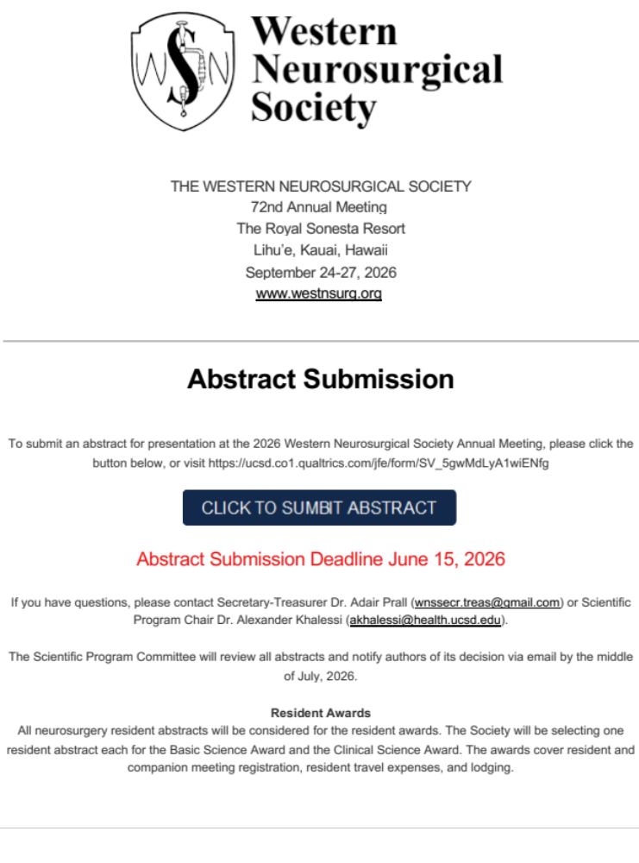

More information for each event and activity:

OPENING RECEPTION

Thursday, September 24th 6:00-9:30 pm
Please join us at the Royal Sonesta Resort for our opening reception. Enjoy a buffet dinner and drinks in this outdoor location with a nationally recognized traditional slack-key guitarist Paul Togioka providing music for the event.

LOCALS NIGHT EVENT

Friday, Sept 25th 6:00-9:30pm
Join us for a traditional Hawaiian luau on the grounds of the hotel, next to the ocean. Members and guests will enjoy live music, dinner and drinks, and most exciting, traditional hula and fire dancing.

FORMAL BANQUET

Saturday, Sept 26th 6:00-11:00pm
Please join us for a black tie (optional) evening including a cocktail hour, seated dinner, new member induction, and music in the main ball room at the hotel.
Children ages 3 to 12 will be entertained, fed and supervised near the banquet in a separate room. Children must be potty trained. This is included in your registration. Further details will be sent to those who want to take advantage of this childcare option for the formal banquet.

AFTERNOON ACTIVITIES
Wailua River Cruise
Friday, Sept 25th, 1:30-4:00pm. $85 per person. Includes transportation, boat ride and beautiful scenery!

Kids are welcome. Activity level mild.
Spend a delightful day exploring the natural and cultural wonders of Kauai without having to rent a car on this excursion featuring the magnificent Wailua River, Opaekaa Falls, and Fern Grotto. Learn more about the island along the way! Pristine waters, untouched habitat in all directions, and the warm sun define this family friendly adventure. This trip is perfect for families with small children.
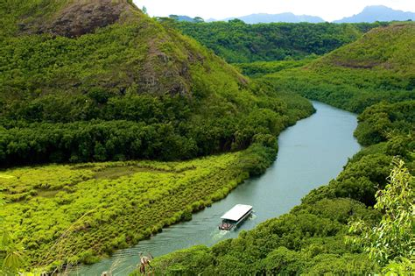
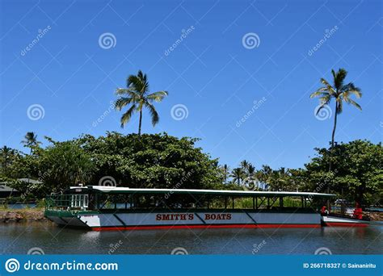

Kipu Ranch ATV Tour
Friday, Sept 25th, 12:30-5:00pm. $290 per person. Includes transportation, guide, gear. Minimum Age: 9. Two-four people per vehicle.
Ride through lush green pastures, venture down into tropical Huleia Valley, and ascend under the canopy of the rainforest, as it leads you to the breathtaking backdrop of Mt. Haupu, Kauai’s untouched paradise. Explore iconic movie locations, breathtaking waterfalls, and fascinating jungle wildlife.
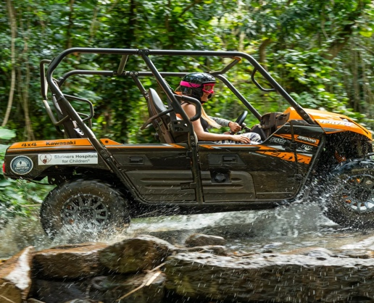
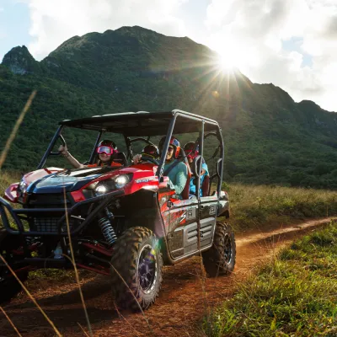

Helicopter Tour
Saturday, Sept 26th, 1:30-3:30pm, 2:30-5:15pm. $390 per person. Minimum weight 40lb; Maximum weight 275lb. Minimum age 11.
Ready for a doors-off thrill seekers adventure tour with seating up to four with no middle rear seat for optimal viewing and photography? Get ready to see Kauai’s shoreline, waterfalls, and canyons from a bird’s eye view.
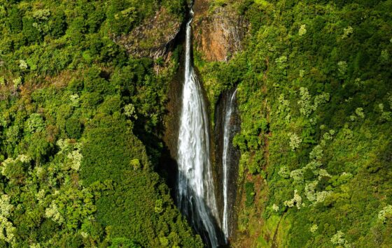
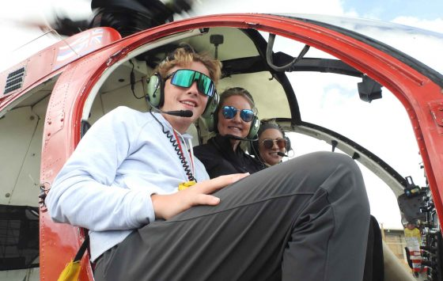
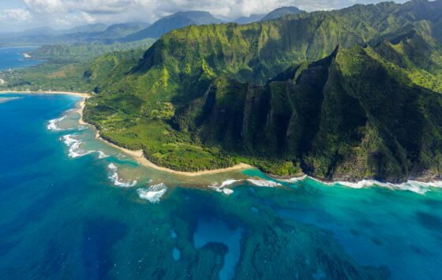

River Tubing
Saturday, Sept 13th, 12:30-4:30pm. $230 per person. Minimum age 4, minimum height 43”; maximum weight 300lb
Witness Kauai’s spectacular, historic engineering feats as you float down the open Witness Kauai’s spectacular, historic engineering feats as you float down the open canals and through five amazing tunnels and flumes engineered and hand-dug circa 1870! This tubing adventure is perfect for people ages 5 and over in generally good physical condition. The gently flowing waters, beautiful scenery, flumes and tunnels create a relaxing, fun and fascinating adventure. Enjoy exclusive access to 17,000 acres of former plantation lands.
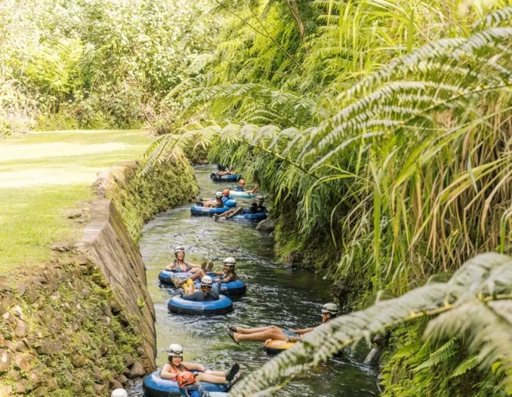

ADDITIONAL ACTIVITY INFORMATION

Alternative Activities

- The Visit Old Koloa Town for shopping and local eats.
- Waimea Canyon Lookout & Red Dirt Waterfall driving tour with epic views. Add the Iliau Nature Loop Trail (0.3 mi) to see flowering lliau native Hawaiian plants.
- Poipu Beach for snorkeling and local beaches.
- Kilauea Point National Wildlife Refuge for pelagic birds.
- Wailua Hindu Monastery gardens and waterfall viewing tour.
- Maha’ulepu Heritage Trail (3.8 mi, 400 ft gain, 1.5 hr)
- Rum Safari(2.5 hours) or Koloa Rum Tasting(?time)
- Surf Lessons(at the hotel; 1.5 hours, minimum age 9)
- Local farmers markets on Saturdays only.
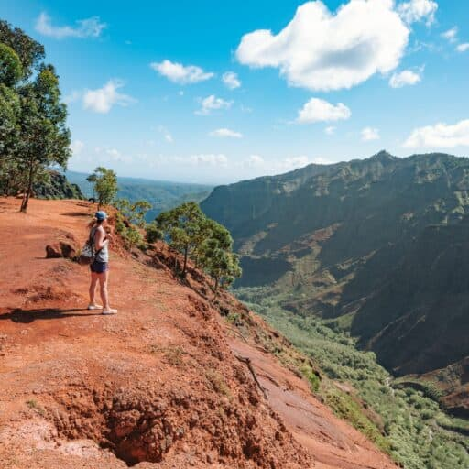
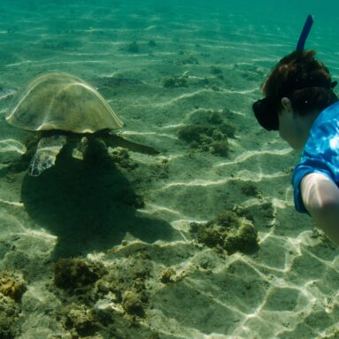

Resort Activities
In addition to the group activities, the hotel offers multiple adventures including snorkeling, boating, paddle boarding, kayaking, surfing and hiking. Several world class golf courses are nearby, including The Ocean Course at Hokuala, and Puakea. For a slightly slower pace consider checking out the local shops or parks.
